**DBMS**

**EXPERIMENT - 7**

|  |  |  |  |  |  |  |
| --- | --- | --- | --- | --- | --- | --- |
| **Exp. No** | **Conducted on** | **Submitted On** | **Date of Late Submission**  **(if Any)** | **Max Marks Allotted** | **Marks Obtained** | **Faculty Signature** |
| 1 | 16/03/2022 | 23/03/2022 |  | 10 |  |  |
| **Exp Title** | Join Queries | | | | | |

**Aim**

To join tables using the Join in SQL queries.

**Syntax**

SELECT table1.column, table2.column

FROM table1, table2

WHERE table1.column1 = table2.column2;

**Queries:**

CREATE TABLE "ORDERS"

(

"ORD_NUM" NUMBER(6,0) NOT NULL PRIMARY KEY,

"ORD_AMOUNT" NUMBER(12,2) NOT NULL,

"ADVANCE_AMOUNT" NUMBER(12,2) NOT NULL,

"ORD_DATE" DATE NOT NULL,

"CUST_CODE" VARCHAR2(6) NOT NULL REFERENCES CUSTOMER,

"AGENT_CODE" CHAR(6) NOT NULL REFERENCES AGENTS,

"ORD_DESCRIPTION" VARCHAR2(60) NOT NULL

);

INSERT INTO ORDERS VALUES('200100', '1000.00', '600.00', '08/01/2008', 'C00013', 'A003', 'SOD');

INSERT INTO ORDERS VALUES('200110', '3000.00', '500.00', '04/15/2008', 'C00019', 'A010', 'SOD');

INSERT INTO ORDERS VALUES('200107', '4500.00', '900.00', '08/30/2008', 'C00007', 'A010', 'SOD');

INSERT INTO ORDERS VALUES('200112', '2000.00', '400.00', '05/30/2008', 'C00016', 'A007', 'SOD');

INSERT INTO ORDERS VALUES('200113', '4000.00', '600.00', '06/10/2008', 'C00022', 'A002', 'SOD');

INSERT INTO ORDERS VALUES('200102', '2000.00', '300.00', '05/25/2008', 'C00012', 'A012', 'SOD');

INSERT INTO ORDERS VALUES('200114', '3500.00', '2000.00', '08/15/2008', 'C00002', 'A008', 'SOD');

INSERT INTO ORDERS VALUES('200122', '2500.00', '400.00', '09/16/2008', 'C00003', 'A004', 'SOD');

INSERT INTO ORDERS VALUES('200118', '500.00', '100.00', '07/20/2008', 'C00023', 'A006', 'SOD');

INSERT INTO ORDERS VALUES('200119', '4000.00', '700.00', '09/16/2008', 'C00007', 'A010', 'SOD');

INSERT INTO ORDERS VALUES('200121', '1500.00', '600.00', '09/23/2008', 'C00008', 'A004', 'SOD');

INSERT INTO ORDERS VALUES('200130', '2500.00', '400.00', '07/30/2008', 'C00025', 'A011', 'SOD');

INSERT INTO ORDERS VALUES('200134', '4200.00', '1800.00', '09/25/2008', 'C00004', 'A005', 'SOD');

INSERT INTO ORDERS VALUES('200108', '4000.00', '600.00', '02/15/2008', 'C00008', 'A004', 'SOD');

INSERT INTO ORDERS VALUES('200103', '1500.00', '700.00', '05/15/2008', 'C00021', 'A005', 'SOD');

INSERT INTO ORDERS VALUES('200105', '2500.00', '500.00', '07/18/2008', 'C00025', 'A011', 'SOD');

INSERT INTO ORDERS VALUES('200109', '3500.00', '800.00', '07/30/2008', 'C00011', 'A010', 'SOD');

INSERT INTO ORDERS VALUES('200101', '3000.00', '1000.00', '07/15/2008', 'C00001', 'A008', 'SOD');

INSERT INTO ORDERS VALUES('200111', '1000.00', '300.00', '07/10/2008', 'C00020', 'A008', 'SOD');

INSERT INTO ORDERS VALUES('200104', '1500.00', '500.00', '03/13/2008', 'C00006', 'A004', 'SOD');

INSERT INTO ORDERS VALUES('200106', '2500.00', '700.00', '04/20/2008', 'C00005', 'A002', 'SOD');

INSERT INTO ORDERS VALUES('200125', '2000.00', '600.00', '10/10/2008', 'C00018', 'A005', 'SOD');

INSERT INTO ORDERS VALUES('200117', '800.00', '200.00', '10/20/2008', 'C00014', 'A001', 'SOD');

INSERT INTO ORDERS VALUES('200123', '500.00', '100.00', '09/16/2008', 'C00022', 'A002', 'SOD');

INSERT INTO ORDERS VALUES('200120', '500.00', '100.00', '07/20/2008', 'C00009', 'A002', 'SOD');

INSERT INTO ORDERS VALUES('200116', '500.00', '100.00', '07/13/2008', 'C00010', 'A009', 'SOD');

INSERT INTO ORDERS VALUES('200124', '500.00', '100.00', '06/20/2008', 'C00017', 'A007', 'SOD');

INSERT INTO ORDERS VALUES('200126', '500.00', '100.00', '06/24/2008', 'C00022', 'A002', 'SOD');

INSERT INTO ORDERS VALUES('200129', '2500.00', '500.00', '07/20/2008', 'C00024', 'A006', 'SOD');

INSERT INTO ORDERS VALUES('200127', '2500.00', '400.00', '07/20/2008', 'C00015', 'A003', 'SOD');

INSERT INTO ORDERS VALUES('200128', '3500.00', '1500.00', '07/20/2008', 'C00009', 'A002', 'SOD');

INSERT INTO ORDERS VALUES('200135', '2000.00', '800.00', '09/16/2008', 'C00007', 'A010', 'SOD');

INSERT INTO ORDERS VALUES('200131', '900.00', '150.00', '08/26/2008', 'C00012', 'A012', 'SOD');

INSERT INTO ORDERS VALUES('200133', '1200.00', '400.00', '06/29/2008', 'C00009', 'A002', 'SOD');

select cust_name,ord_amount

from CUSTOMER,ORDERS

where CUSTOMER.cust_code=ORDERS.cust_code

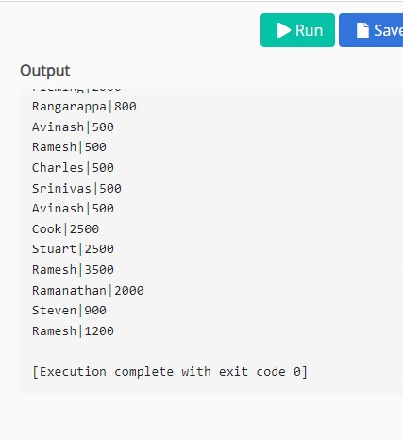

select cust_name,ord_amount,advance_amount

from CUSTOMER,ORDERS

where CUSTOMER.cust_code=ORDERS.cust_code

and advance_amount>500;

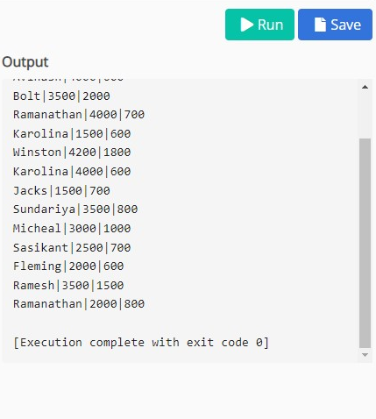

select avg(ord_amount)

from CUSTOMER,ORDERS

where customer.cust_code=orders.cust_code

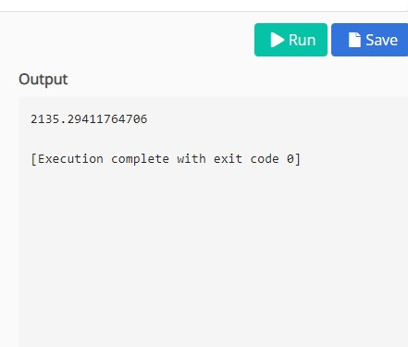

**Result**

Thus the JOIN queries were successfully executed and verified.